Overview

- These instructions define how to annotate objects in LiDAR point cloud data using 3D cuboids (bounding boxes). Annotations must be complete, consistent, and tightly fitted to the object in every frame.
- The ontology covers different object classes across different groups: person, Dynamic Objects, and Static Objects. Every visible object from this list within a radius of 10m must be annotated in every frame where it appears.
- The goal of this module is to train annotators to accurately identify and label the dynamic objects like Human, Humanoid Robot, Forklift, Pallet Jack, Cart, AGV / AMR, Wheelchair, Vehicle and Static objects like Pallet, Tote, Bin, Rack, Shelf, Conveyor, Workstation, Table, Chair etc. with high consistency.

General Instructions

- Draw 3D bounding boxes (cuboids) around all objects from the label list, and assign the correct label.
- Do not apply more than one cuboid to a single object.
- Check every cuboid in every frame to ensure all LiDAR points are contained within the cuboid.
- The cuboid center must be the geometric center of the entire object, including parts not currently visible.
- Cuboid orientation: the length axis must align with the object's direction of travel; the height axis points upward; the width axis is perpendicular to both.
- Object IDs must remain consistent across all frames in which the object appears. Do not switch IDs between objects.
- IDs must be unsigned integers (e.g. 0, 1, 2). The order they are assigned is not important.
- The cuboids should be properly aligned with the object in the 2D image. Please ensure the 3D cuboid fits the visible 2D object correctly.

Required fields per object
Every cuboid must have:
- Track ID (persistent across frames, never reassigned within a sequence/camera)
- Class ID: one of the 22 ontology classes (Human, Humanoid Robot, Forklift, Pallet Jack, Cart, AGV/AMR, Wheelchair, Vehicle, Pallet, Tote, Bin, Rack, Shelf, Conveyor, Workstation, Table, Chair, Charging Station, Dock Door, Safety Barrier, Machines, Boxes)

- Occlusion state:
  - None = >90% visible
  - Partial = 30-90% visible
  - Heavy = <30% visible
- Motion state: Static / Moving (present on every class)

Training Looms
Please refer to the Loom videos below for reference.
- Setup: https://www.loom.com/share/e01e80c674384db7a09ad9e9f0b17ec6
- Dynamic object labelling: https://www.loom.com/share/3b33283ee63d44c496ef14108b7842cf
- Static object labelling: https://www.loom.com/share/92ca6a7cc27942babea3eef23cc31666
- Stereo annotation for aligning with respect to the image: https://www.loom.com/share/fe2d4e04e074429983278944554d174f
- Merging pre-labels: https://www.loom.com/share/2f6afab31b5446eb8da51e81901507c7

Pre-labelled cuboids

The pre-labels are cuboids generated by a model to assist with the annotation process. While working on the tasks, annotators should carefully review each pre-label and check whether it is relevant to the objects covered under their respective branch.
- If the pre-label is relevant: Review the cuboid carefully, change its class to the appropriate ontology/class, and make sure it is properly aligned with the object across every frame.
- If the pre-label is not relevant: Delete the pre-label and continue annotating the other relevant objects in the task.
Please make sure that all pre-labels are reviewed rather than being accepted as-is

Regions of interest

ROI: 0-5 needs to be perfect quality (5% error)
ROI 2: 0-10 everything labelled
ROI 3: >10m is good but optional if lidar points are bad

Object Taxonomy

Dynamic Objects

Human
- Humanoid Robot
- Forklift
- Pallet Jack
- Cart
- AGV / AMR
- Wheelchair
- Vehicle

Static Objects
- Pallet
- Tote
- Bin
- Rack
- Shelf
- Conveyor
- Workstation
- Table
- Chair
- Charging Station
- Dock Door
- Safety Barrier
- Machines
- Boxes

Human

A person present in the scene, in any posture or activity (Standing, Walking, Running, Sitting, Kneeling, Bending, In-Wheelchair/ADA, etc.). Cuboid covers the full expected body volume, including any occluded portion.
Cuboids shall encompass the expected physical body volume including:
- Head
- Torso
- Arms
- Legs
For partially occluded humans, annotators shall estimate the hidden body portion and maintain a physically representative cuboid.
Cuboids shall not be reduced solely to fit visible pixels.

Attribute Options | Examples
Standing | 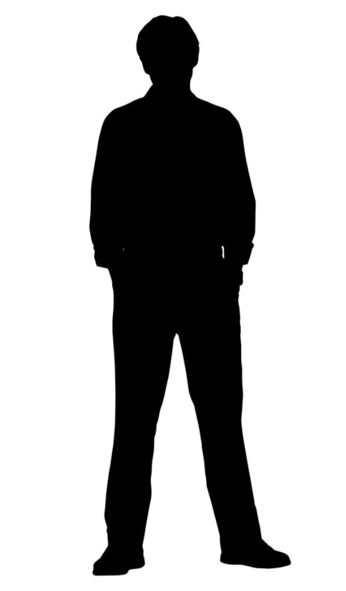
Walking | 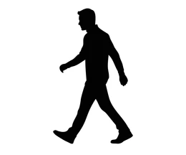
Running | 
Sitting | 
Bending | 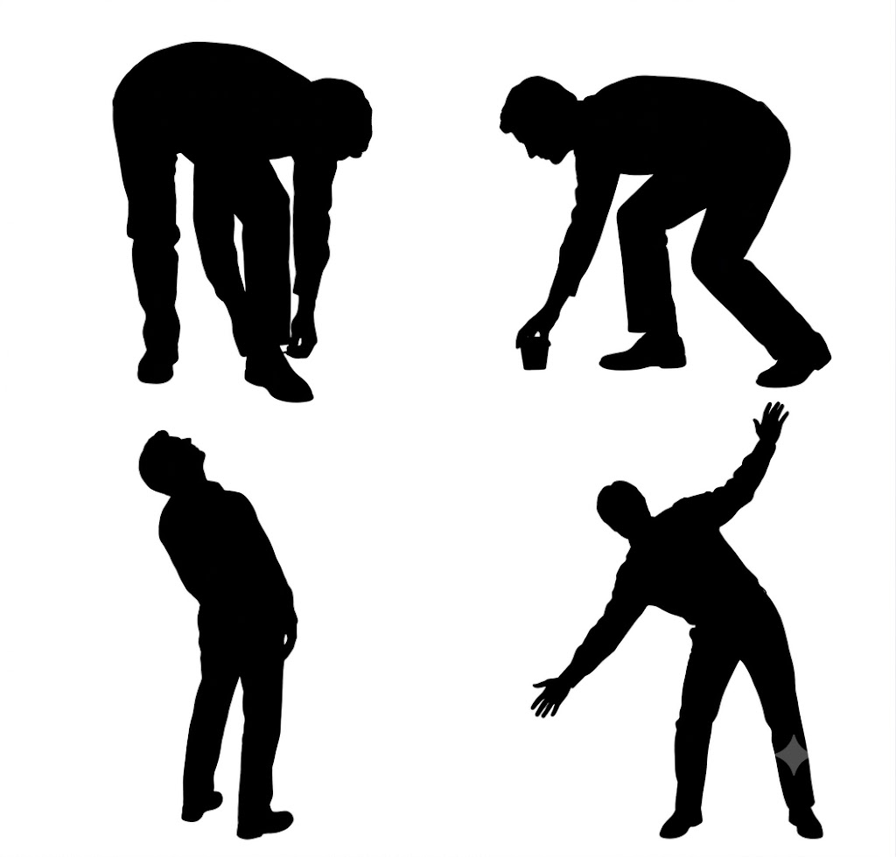
Kneeling | 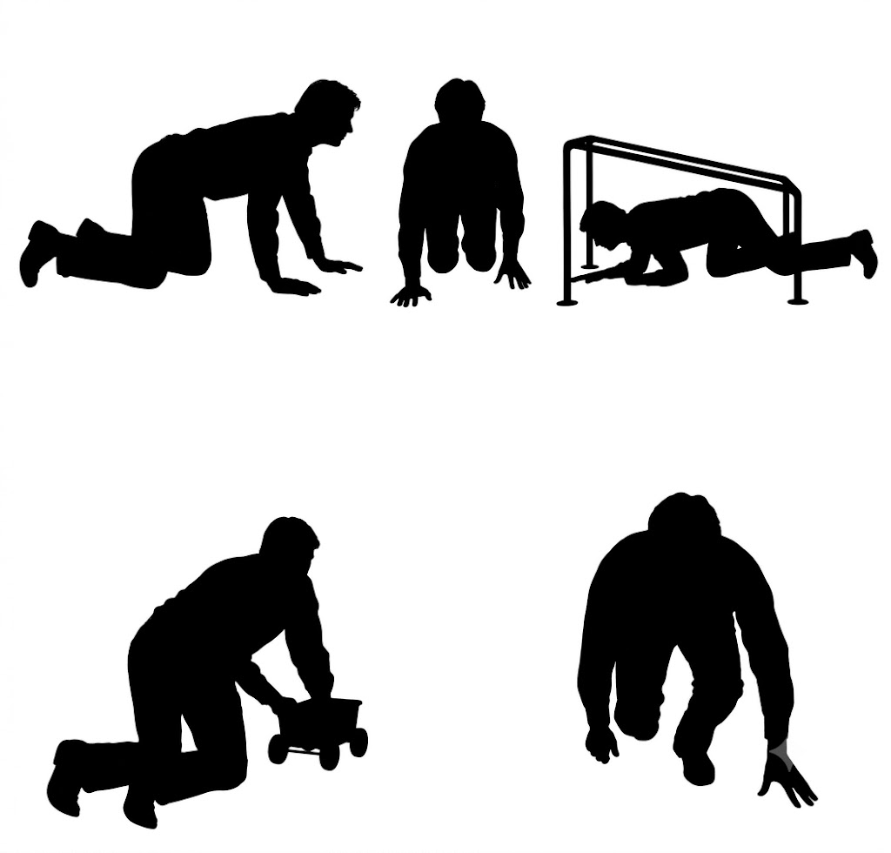
In-wheel-chair | 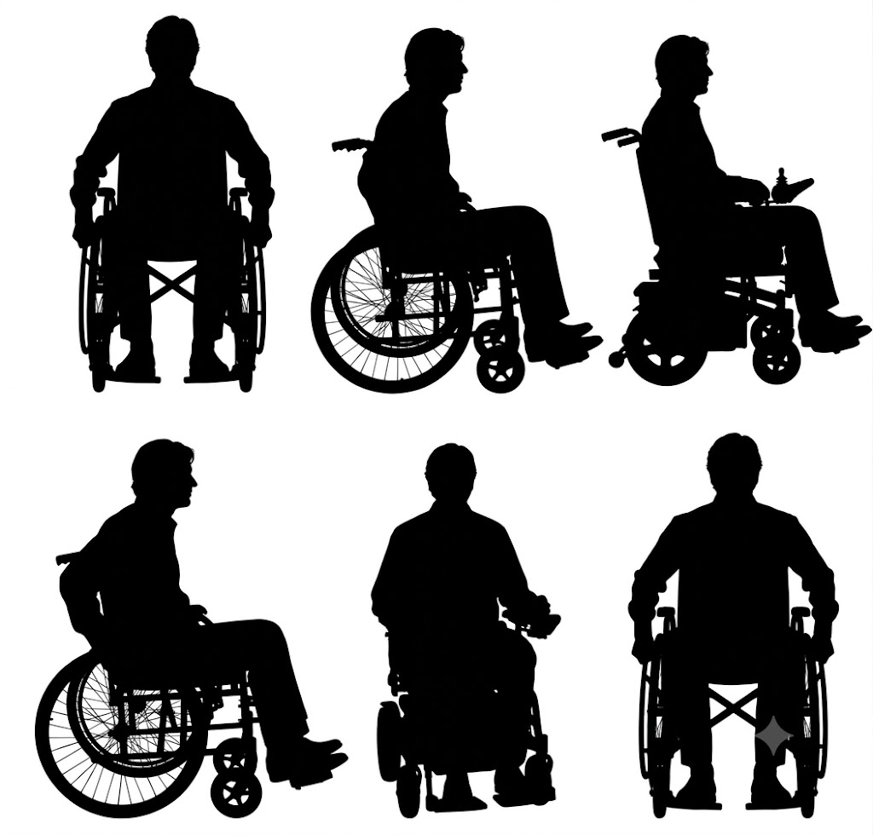
Pushing | 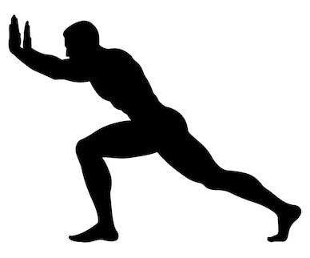
Pulling | 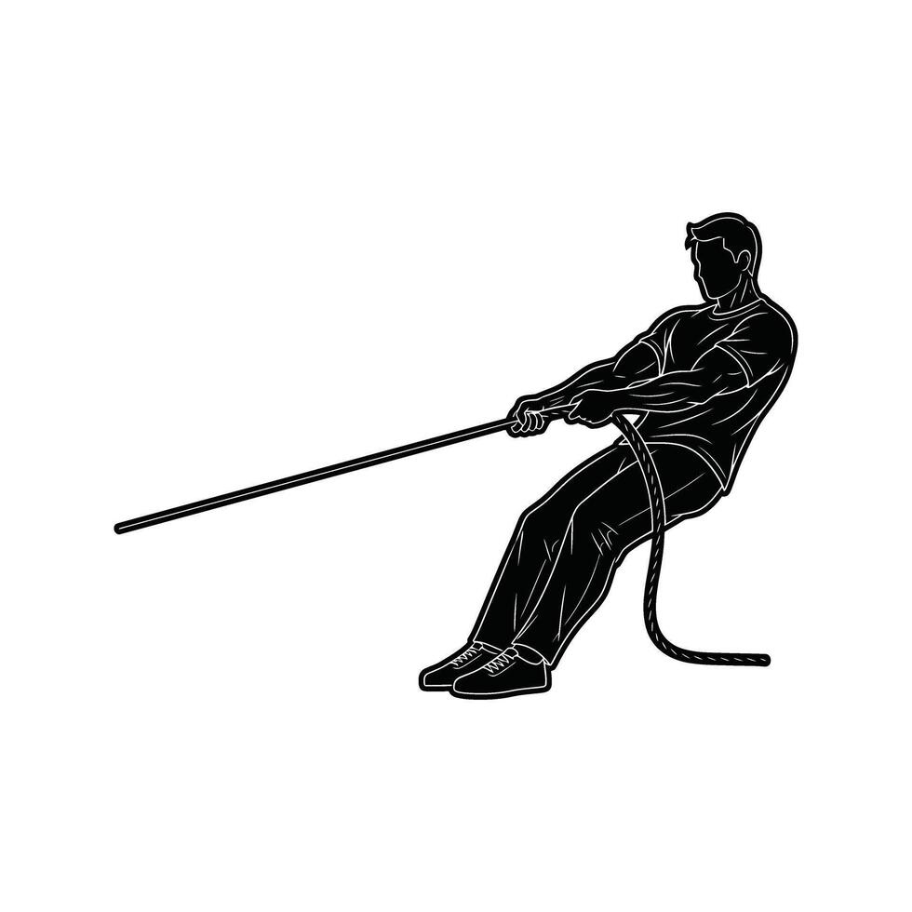
Carrying | 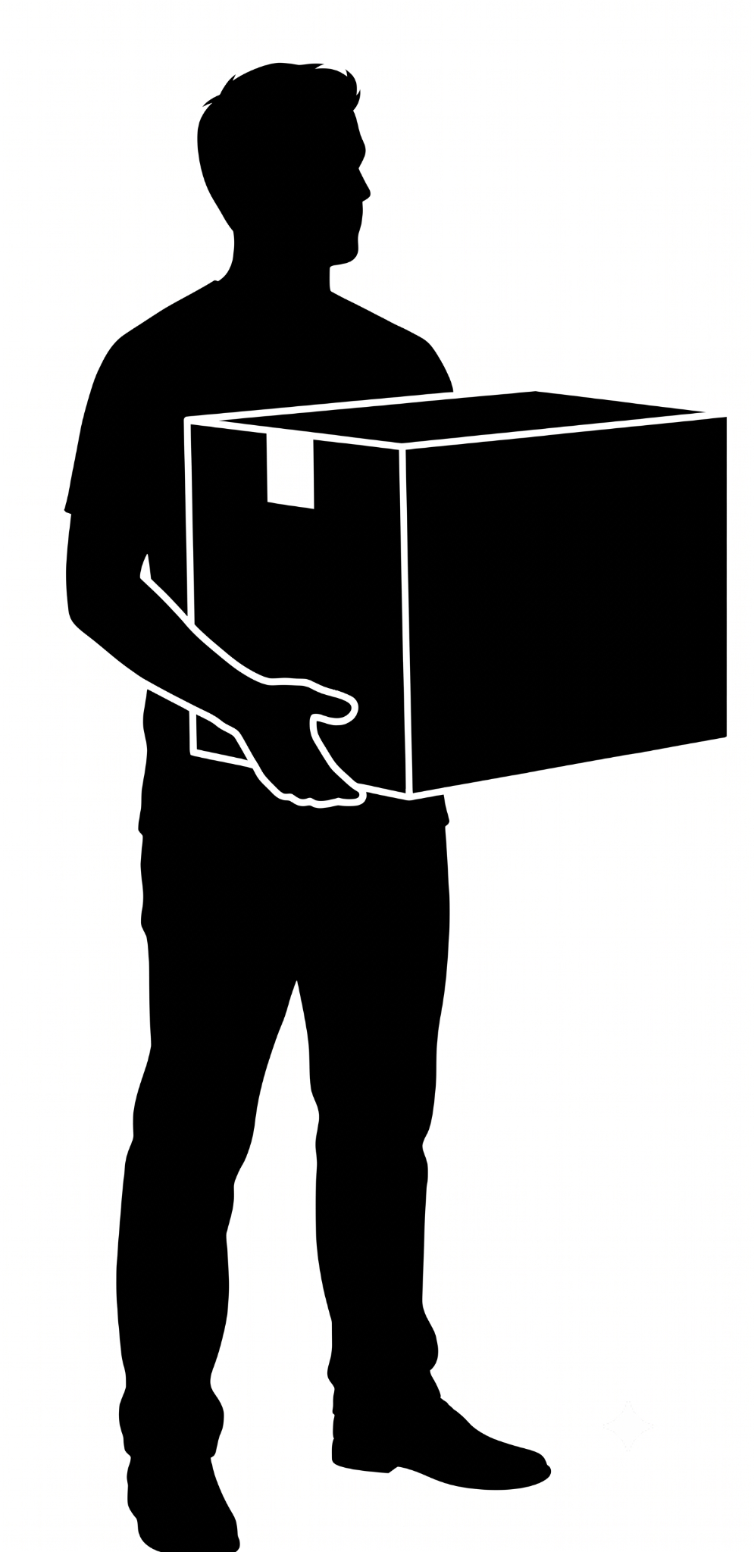
Reaching | 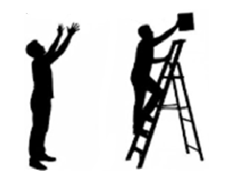

Humanoid Robot

A bipedal, human-shaped robot performing tasks in the facility (e.g. picking, walking). Not a person - a robot built with a human-like body plan.

For articulated poses, the cuboid shall represent the overall occupied space of the robot.
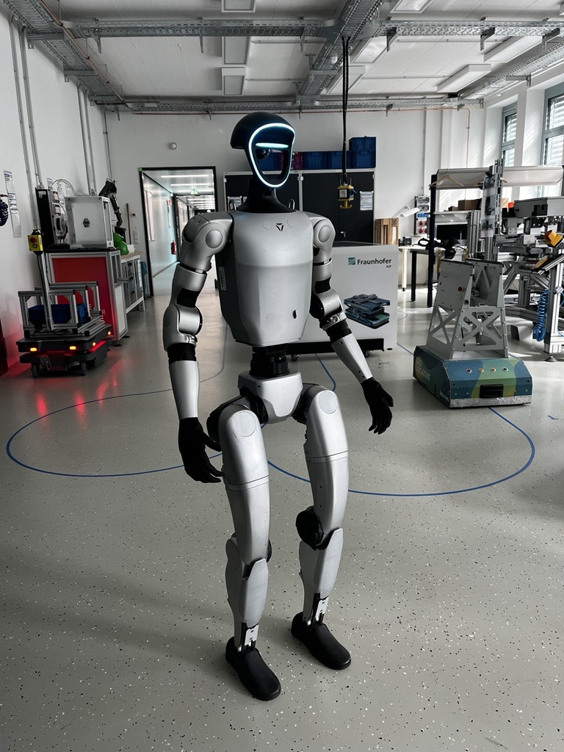

Forklift

A powered industrial truck with a fork/mast assembly used to lift and move palletized loads. Cuboid includes chassis, operator compartment, and forks.

Cuboids shall encompass:
- Chassis
- Operator compartment
- Integrated fork assembly
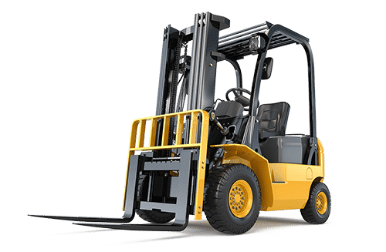

Pallets Jacks

A low-profile manual or powered truck with two forks that slide under a pallet to lift and move it short distances. Lower and smaller than a forklift; no raised mast.

Cuboids shall encompass:
- Pallet footprint
- Attached load when permanently associated with the pallet

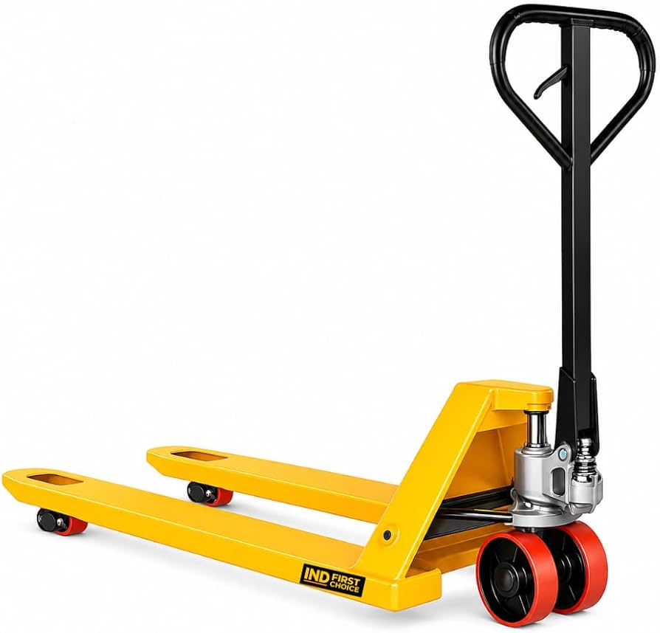

Cart

A wheeled, hand-pushed or hand-pulled cart used to carry goods, tools, or totes (e.g. a push cart or hand truck). Not motorized and not a pallet jack.

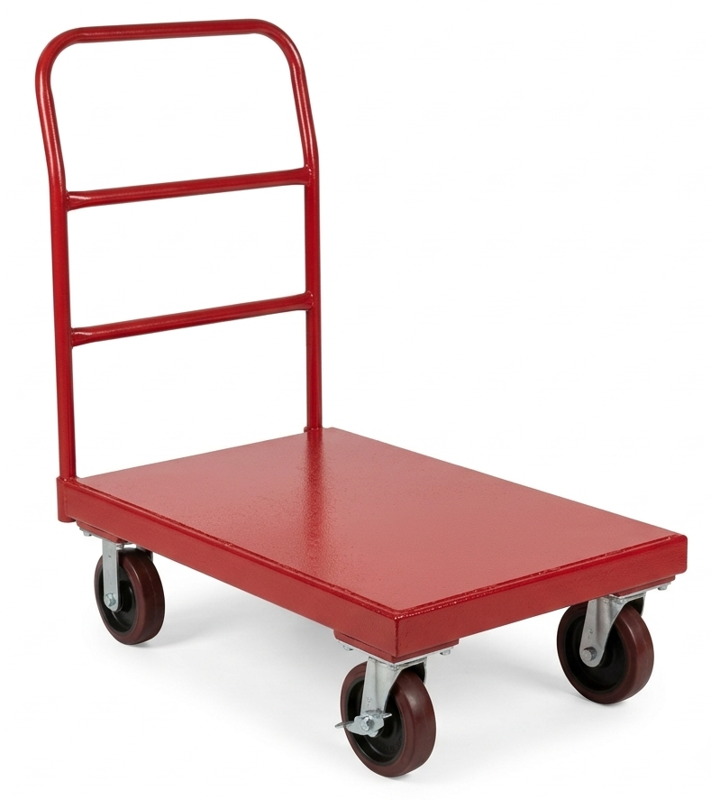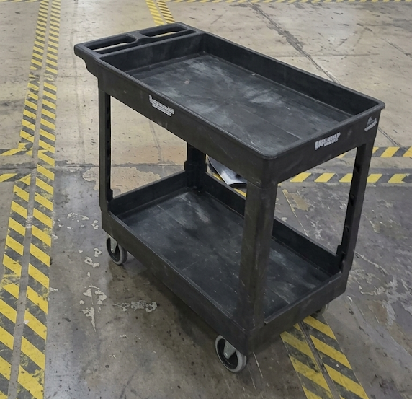

AGV/ AMR

An Automated Guided Vehicle or Autonomous Mobile Robot: a driverless, self-navigating robotic vehicle that moves goods without an onboard human operator.
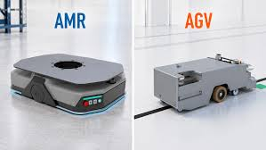

WheelChair

A wheeled mobility device. Annotate the device itself with this class; if a person is using it, also annotate the person as Human with activity state In-Wheelchair/ADA.
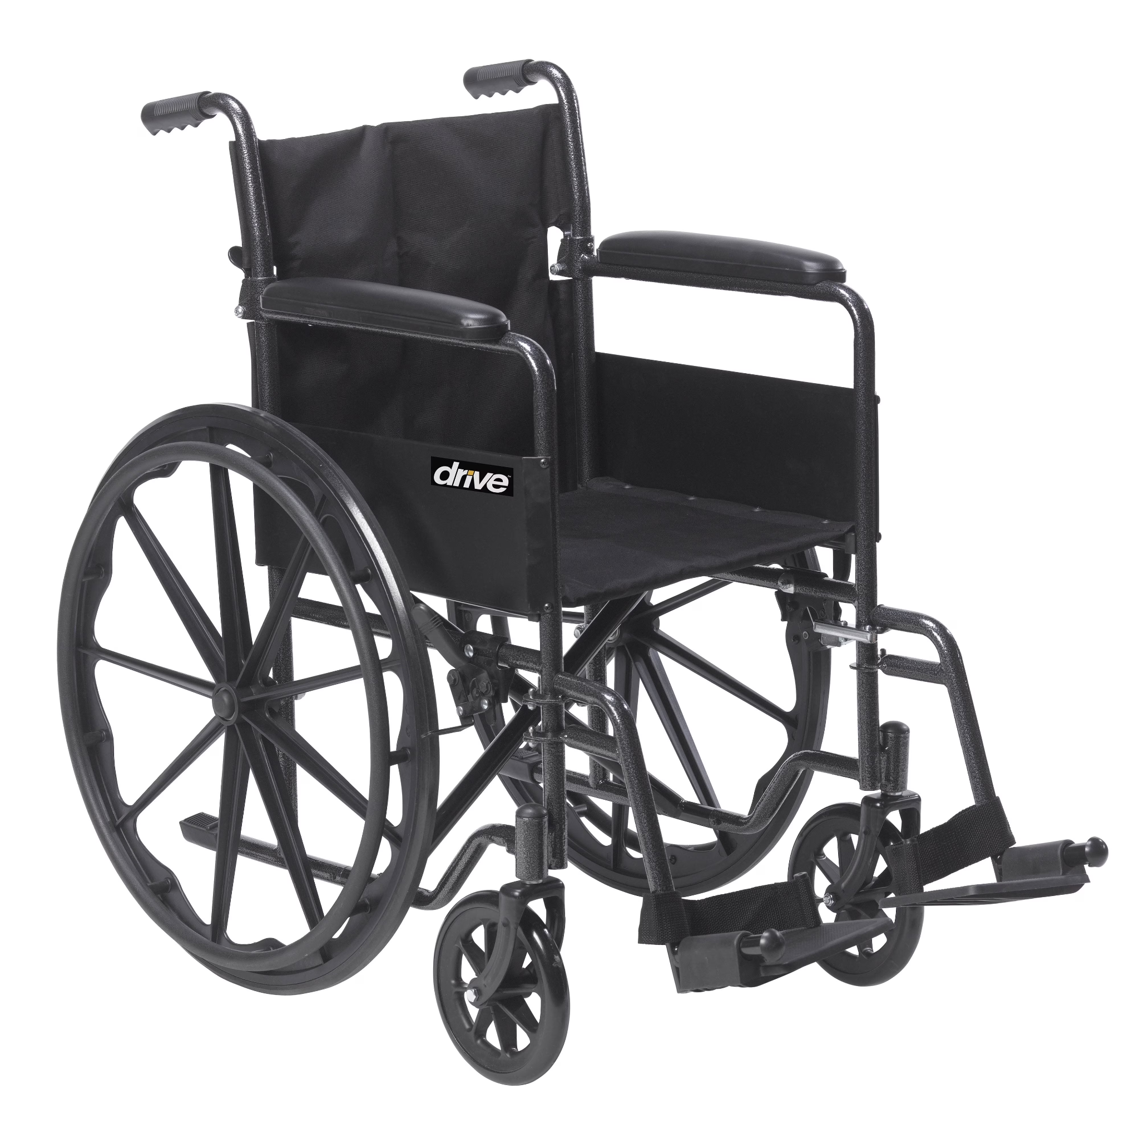

Vehicle

Any motorized vehicle which doesn’t belong to the other mentioned category.

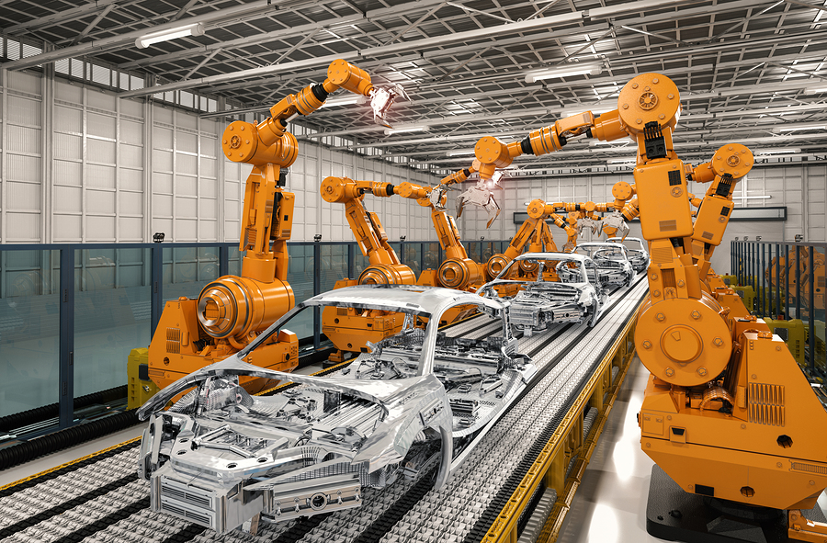

Pallet

A flat wooden or plastic transport structure used as a base for stacking goods. Cuboid covers the pallet footprint plus any load permanently attached to it.

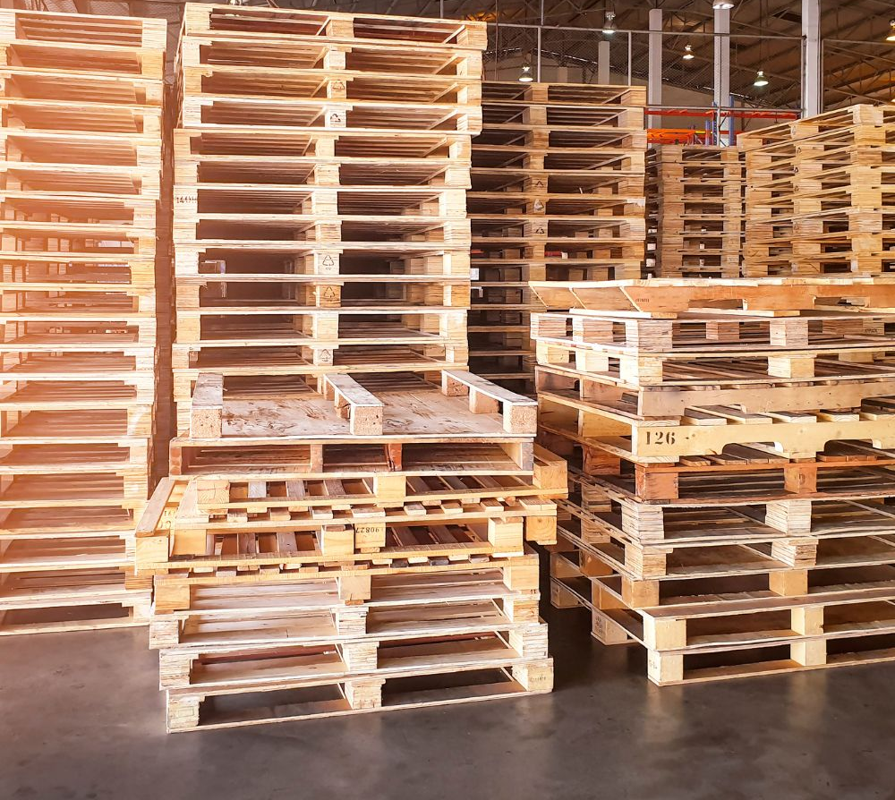

Tote

A rigid, reusable container used to hold and transport smaller items, per the customer's tote/bin class reference. Not a loose cardboard box.

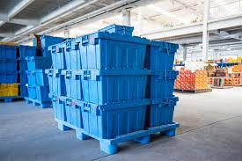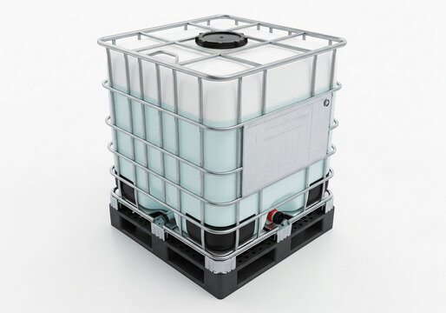

Bin

A rigid, reusable storage container, distinct from Tote per the customer's class reference and distinct from Boxes (which are non-rigid/disposable).

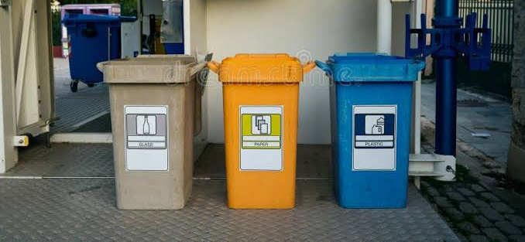

Rack

A multi-level storage structure that holds palletized or shelved goods. Annotate each rack section individually - never combine a full aisle into one cuboid.
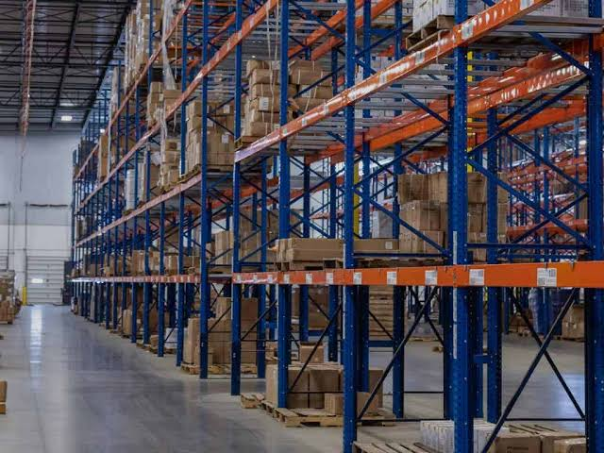

Shelf

An individual shelving unit or level used to store smaller, non-palletized items (distinct from a full Rack structure).
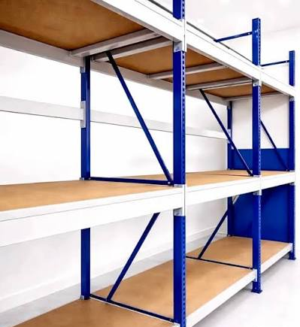

Conveyer

A belt, roller, or powered system used to move goods along a fixed path.A belt, roller, or powered system used to move goods along a fixed path.



Work Station

A fixed work area or setup (e.g. a packing or sorting station) where a task is performed.

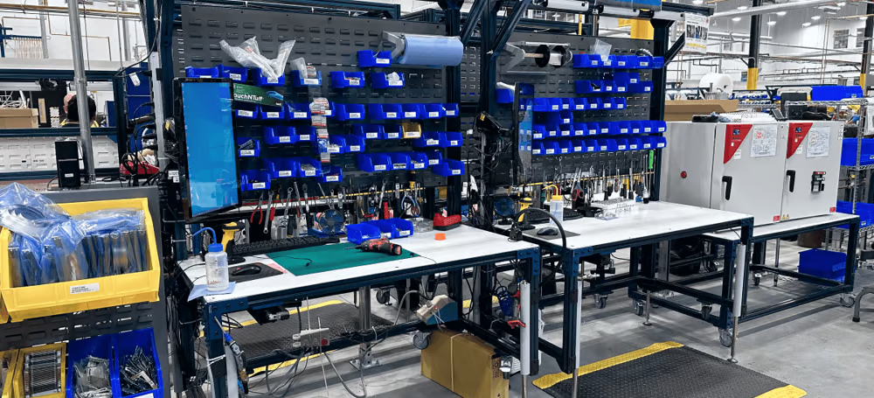

Table

A general-purpose flat-surface furniture item, not part of a dedicated workstation.
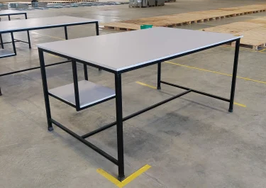

Chair

A seating furniture item.

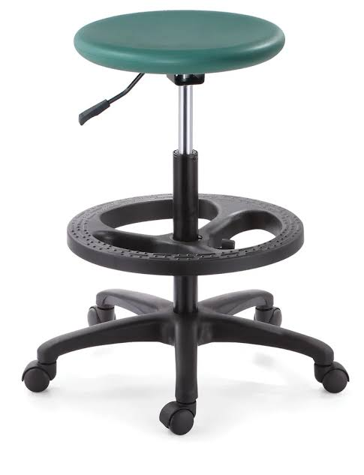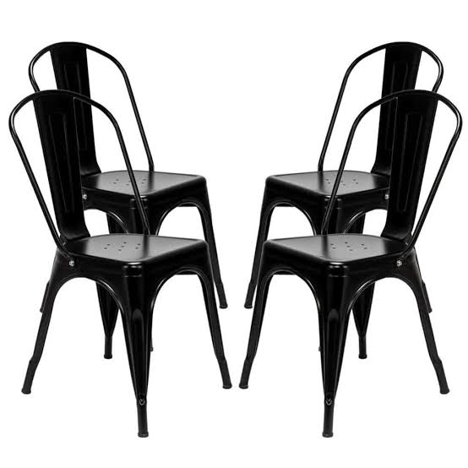

Charging Station

Fixed equipment used to charge batteries for equipment such as forklifts, AGVs/AMRs, or other powered vehicles.

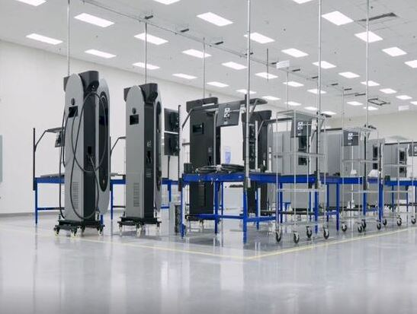

Dock Door

A loading dock door or bay opening used for loading/unloading trailers.
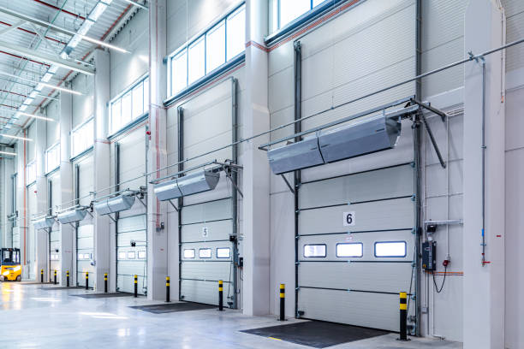

Safety Barrier

A physical barrier (railing, bollard, guard) installed to protect people, equipment, or defined zones.
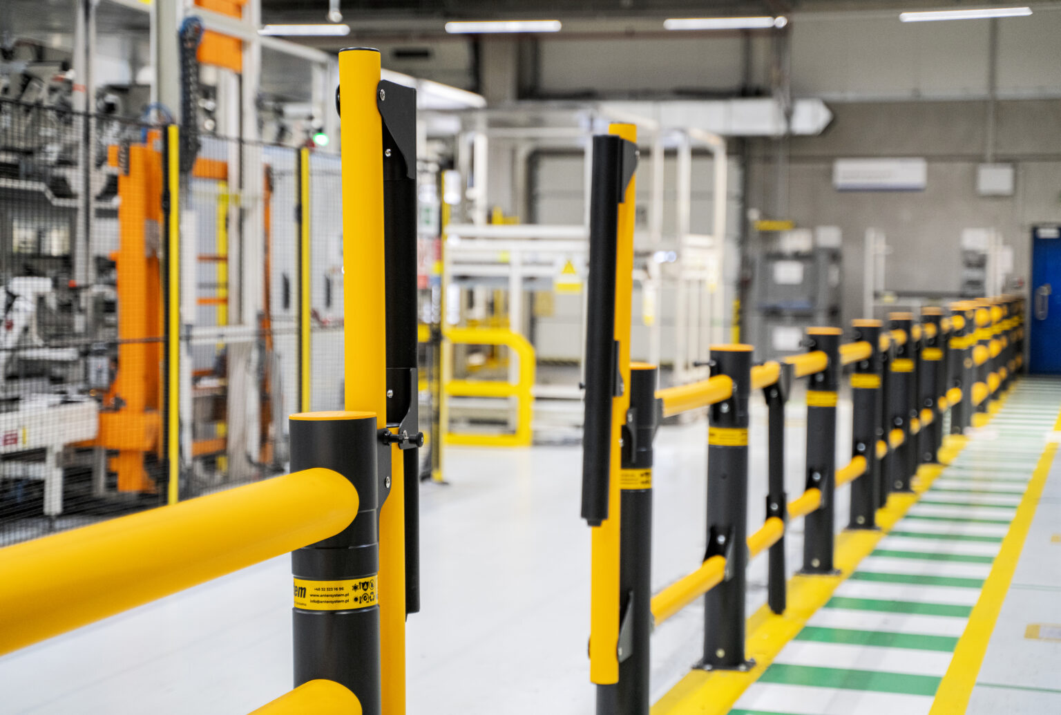

Machines

Industrial machinery in the scene that does not fit any other class.

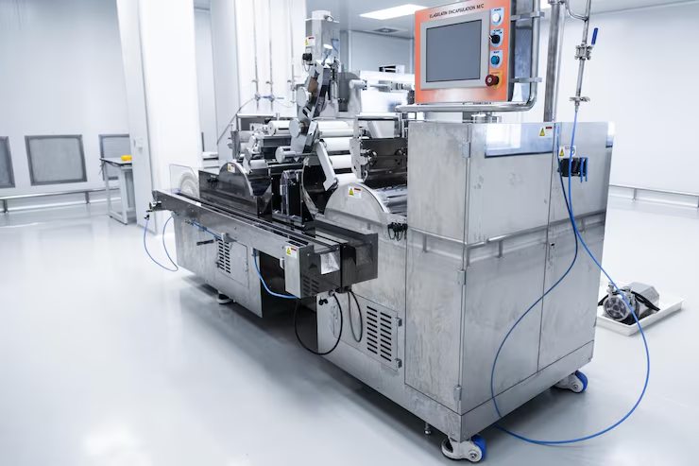

Boxes

A loose cardboard box or shipping carton (not a rigid reusable container). Cuboid includes any lid/flap overhang; annotate stacked-but-separable boxes individually, not as one stack cuboid.



